Exam I (Version 1) | Biology 1010 | Spring 2004
(Answer Key at bottom)
Be sure to fill in your student name and number on the scantron. When you’re through with the exam, place your scantron on the pile corresponding to this version of the exam. Your scores will be sent to you automatically if you have an active cc.usu.edu e-mail account. There are 50 questions. Ask if you have questions about the interpretation of any question. I will attempt to help as long as what you ask is not directed at what I am testing.
- The concept of provisional assent of scientific theories implies that:
  - many hypotheses are true
  - many hypotheses are false
  - scientific knowledge is absolute
  - scientific knowledge is not absolute
  - the methods of science can and must be applied to all areas of inquiry

- In the scientific context, a theory is:
  - a falsifiable (testable) prediction
  - an “educated guess”
  - an undisputed piece of information derived from observation
  - something known to be absolutely true
  - a set of principles never proven wrong that explain some broad natural phenomenon

- Which aspect of the scientific method allows would reveal personal differences between individuals who apply this method (i.e., differences in the approaches taken by different scientists)?
  - Observation
  - Posing a question
  - Formulating a hypothesis
  - All the above
  - None of the above

- Properties of successively higher levels of organizational complexity in biology (i.e., going from molecules, to organelles, to cells, to organs, to organisms, etc.):
  - are completely predictable from the properties of lower levels.
  - are only partially predictable from the properties of lower levels, with some new properties (emergent properties) evident.
  - cannot in any way be predicted form the properties of lower levels.
  - do not follow laws of chemistry or physics.
  - do not follow the laws of thermodynamics.

- A particular type of atom, carbon for example, always has the same number of:
  - protons
  - neutrons
  - protons and neutrons
  - protons, neutrons and electrons
  - protons, neutrons, electrons, and nutrinos

- The following figure was shown in lecture to illustrate:
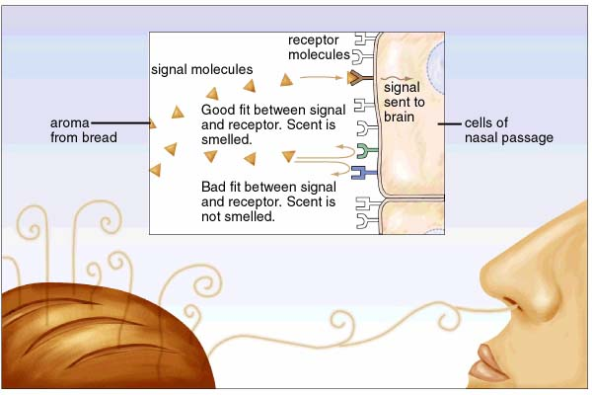
  - that odors must travel through the air.
  - that the nose is the sensory organ for odor detection.
  - that odors are receptor molecules.
  - that molecular shape is important in biology.
  - that the physical sciences, such as physics and chemistry, have little importance in biology.

- Which of the following is a molecule?
  - e⁻ (an electron)
  - H⁺
  - Cl⁻
  - He
  - C₆H₁₂O₆

- Nitrogen contains 7 protons. Therefore, in covalent bonds with other atoms, nitrogen “seeks” _____________ electrons.
  - 1
  - 2
  - 3
  - 4
  - 7

- A covalent bond is one: __________.
  - in which atoms share electrons
  - in which atoms are attracted by full, opposite electrical charges (i.e. a + and a – charge)
  - in which atoms are attracted by partial, opposing charges
  - found only in the link that connects protein building blocks
  - between water molecules

- Which of the following accounts for water’s unique properties?
  - Its ability to form covalent bonds within a single water molecule
  - Its ability to form covalent bonds between water molecule when in the solid state
  - Its ability to form hydrogen bonds within a single water molecule
  - Its ability to form hydrogen bonds between different water molecules
  - Its ability to form ionic bonds within a single water molecule

- The fact that oxygen is “hungry for electrons” has the consequence that in a water molecule:
  - oxygen is an ion carrying a full positive charge
  - oxygen carries a partial positive charge
  - oxygen is an ion carrying a full negative charge
  - oxygen carries a partial negative charge
  - oxygen will consume electrons and throw out protons

- pH is a measure of:
  - the proton (H⁺) concentration
  - the water concentration
  - the solute concentration
  - the catalyst concentration
  - the tendency of proteins to form ions

- When dissolved in water, lye produces many OH⁻ ions that readily absorb H⁺ to form water. Therefore, lye is a strong:
  - catalyst
  - nucleotide
  - peptide
  - acid
  - base

- Imagine a situation where you are about to bathe your new baby. Just before lifting the baby to the bathwater, your mother-in-law screams “Stop – the pH of that water is 7!” You should:
  - be forever grateful to her saving your child from an acid bath.
  - be forever grateful to her saving your child from a bath in a strong base.
  - be forever grateful to her saving your child from a bath in reactive ions.
  - be forever grateful to her saving your child from potential death by hydrogen bonds.
  - chalk it up to another round of misguided advice.

- The atom that forms the backbone of most biological molecules is:
  - hydrogen
  - oxygen
  - nitrogen
  - carbon
  - phosphorus

- A polar molecule:
  - has its electrons distributed evenly between its atoms
  - has its electrons distributed unevenly between its atoms
  - will not dissolve in water
  - always carries a full positive or negative charge
  - is made only of atoms containing two or 10 protons

- Fats are:
  - hydrophobic
  - hydrophilic
  - always solvents
  - always solutes
  - connected by ionic bonds

- Cellulose is a macromolecule made by linking together many, many glucose molecules. Therefore, cellulose is a _________________ made of glucose __________________.
  - momomer; atoms
  - monomer; polymers
  - monomer; subunits
  - polymer; monomers
  - covalent molecule; bonds

- In the schematic view of a polypeptide shown below, each box represents:
  - a simple sugar
  - a polymer
  - a peptide
  - an amino acid
  - a sterol

- Biologists spend immense amounts of time trying to learn the details of protein structure. The reason for all this effort is:
  - proteins are fascinating molecules
  - the structure of proteins is remarkably complex and beautiful
  - proteins are important and their structure determines their function
  - to work out techniques for learning the structure of DNA, the molecule of life.
  - to be able to learn how proteins are linked together to form cellulose, Earth’s most abundant macromolecule

- The molecule shown in the figure at right is a:
  - protein
  - nucleotide
  - fat
  - phosopholipid
  - sterol

- Cholesterol is:
  - harmful to human health at any level
  - an essential component of cell membranes
  - found only in bacteria
  - an important form of phospholipid
  - a building block of proteins

- The molecule shown in the following figure is used to build:
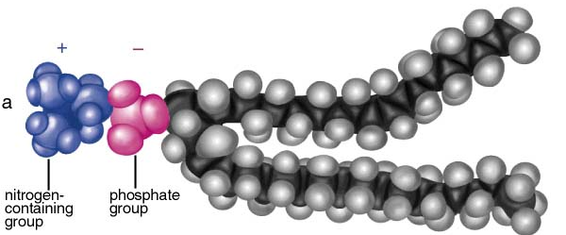
  - the cytoskeleton.
  - cell membranes
  - the nucleus
  - an amino acid
  - a sugar

- DNA and RNA:
  - provide structure to the cell
  - form the cytoskeleton
  - are the primary energy currency of the cell
  - are involved in the storage and flow of genetic information
  - are found in the non-polar core of the phospholipid bilayer

- Phospholipids are able to form a bilayer in water because they:
  - are polar
  - are non-polar
  - contain both polar head groups and non-polar fatty acid tails.
  - associate with proteins
  - anchor the glycocalyx

- The building block of a nucleic acid polymer is a:
  - simple sugar
  - simple acid
  - amino acid
  - nucleotide
  - nitrogenous base

- The figure above shows:
  - amino acids
  - sugars
  - fats
  - nucleic acids
  - DNA

- In terms of the number of individual organisms, the most abundant form of life is:
  - bacteria
  - fungi
  - plants
  - animals
  - people

- The fundamental distinction between prokaryotes and eukaryotes is:
  - prokaryotes don’t have organelles, eukaryotes do
  - prokaryotes have organelles, eukaryotes don’t
  - prokaryotic cells are larger than eukaryotic cells
  - prokaryotes include the bacteria and plants, eukaryotes include only animals
  - prokaryotes include only animals, eukaryotes include bacteria and plants

- The majority of DNA in a plant cell is found in the:
  - nucleus
  - cytosol
  - Golgi apparatus
  - endoplasmic reticulum
  - plasma membrane

- You observe an organelle fuse to and digest a defective mitochondrion. This organelle is a:
  - chloroplast
  - ribosome
  - rough endoplasmic reticulum
  - Golgi apparatus
  - lysosome

- Proteins that will be secreted from the cell are made:
  - inside the nucleus.
  - in the endoplasmic reticulum
  - in the chloroplast
  - in the lysosome
  - in the mitochondria

- Which of the following provides an example of a protein secreted from a cell?
  - Cellulose
  - Starch
  - A hormone
  - Cholesterol
  - A ribosome

- The Golgi apparatus acts as a:
  - control center of the cell.
  - factory for protein synthesis
  - a recycling center
  - the cell’s powerhouse.
  - a protein sorting center

- The part of the cell that is most involved in allowing the animal cell below to “reach out” for the bacterium is the:
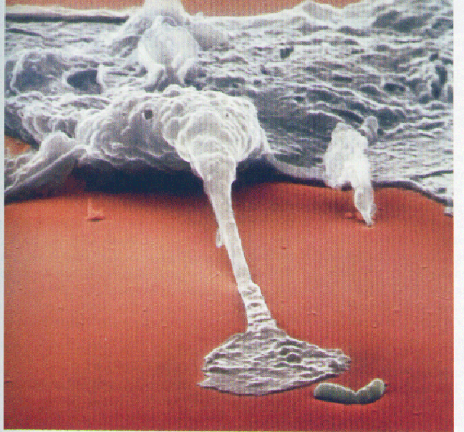
  - nucleus
  - cytosol
  - cytoskeleton
  - endoplasmic reticulum
  - Golgi apparatus

- Which of the following organelles is believed to have come from a long-ago engulfed bacterial cell?
  - The mitochondrion
  - The cytoskeleton
  - The ribosome
  - The Golgi apparatus
  - The plasma membrane

- Materials are carried to and from the Golgi apparatus:
  - in transport vesicles
  - inside proteins
  - within the core of the phospholipid bilayer
  - in the endoplasmic reticulum
  - in the mitochondria

- Plant cells posses __________________, whereas animal cells lack these structures.
  - mitochondria and chloroplasts
  - a plasma membrane and mitochondria
  - a cell wall and mitochondria
  - a cell wall and chloroplasts
  - a cytoskeleton and mitochondria

- The bulk of oxygen in Earth’s atmosphere is produced by:
  - mitochondria
  - cell walls
  - chloroplasts
  - plasma membranes
  - the smooth endoplasmic reticulum

- The organelle most closely associated with cell suicide is the:
  - suicidisome
  - lysosome
  - endoplasmic reticulum
  - nucleus
  - chloroplast

- The plasma membrane contains all the following except:
  - phospholidids
  - cholesterol
  - glycocalyx
  - RNA
  - integral and peripheral proteins

- During diffusion molecules move __________ until they are __________.
  - down their concentration gradients; evenly distributed
  - up their concentration gradients; evenly distributed
  - down their concentration gradients; unevenly distributed
  - up their concentration gradients; unevenly distributed
  - through channels of active transport proteins; evenly distributed

- Which of the following processes requires energy provided by ATP?
  - Cooling of a solution
  - Diffusion in a solution
  - Simple diffusion across the plasma membrane
  - Facilitated diffusion across the plasma membrane
  - Active transport across the plasma membrane

- Cells take in large objects, such as bacteria, by:
  - facilitated transport
  - active transport
  - exocytocis
  - endocytosis
  - simple diffusion

- Which of the following moves across the plasma membrane by simple diffusion?
  - Water
  - Glucose
  - Sodium ions
  - Proteins
  - Bacteria

- An animal cell placed in pure water (not the solute-rich fluid the normally surrounds the cell) will:
  - swim
  - float
  - swell
  - shrik
  - dehydrate

- Plant cells make use of ___________ to press themselves firmly against their cell walls.
  - the cytoskeleton
  - mitochondria
  - ATP
  - active transport
  - osmosis

- The process of diffusion is a consequence of:
  - the First Law of Thermodynamics
  - the Second Law of Thermodynamics
  - osmosis
  - water moving across a semi-permeable membrane
  - endergonic reactions

- Chemical reactions tend to occur spontaneously if:
  - energy is released during the reaction
  - the degree of disorder is increased.
  - they require energy
  - a and b
  - all the above

- The chemical breakdown within our cells of glucose into carbon dioxide and water releases significant amounts of energy. Therefore, this is:
  - an exergonic reaction
  - an endergonic reaction
  - an unfavorable reaction
  - an example of active transport
  - an example of diffusion

Answer Key
1) d | 11) d | 21) e | 31) e | 41) d
2) e | 12) a | 22) b | 32) b | 42) a
3) d | 13) e | 23) b | 33) c | 43) e
4) b | 14) e | 24) d | 34) e | 44) d
5) a | 15) d | 25) c | 35) c | 45) a
6) d | 16) b | 26) d | 36) a | 46) c
7) e | 17) a | 27) a | 37) a | 47) e
8) c | 18) d | 28) a | 38) d | 48) b
9) a | 19) d | 29) a | 39) c | 49) d
10) d | 20) c | 30) a | 40) b | 50) a

